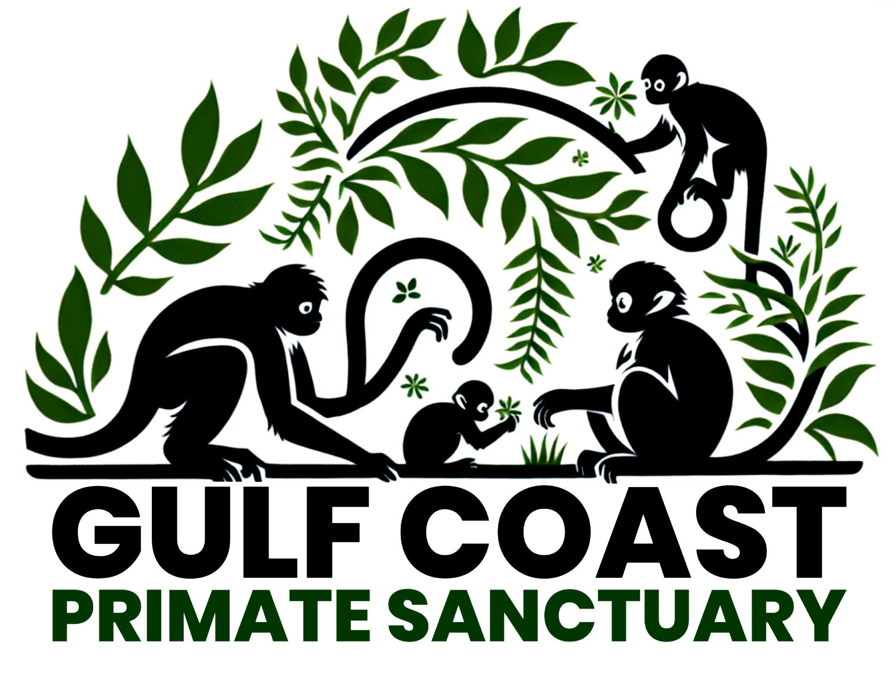
Gulf Coast Primate Sanctuary
70 Inda Rd, Perkinston, MS 39573
1(228)365-6578
info@GulfCoastPrimateSanctuary.org

Board of Directors

April R Stewart
Perkinston, MS 39573
1(228)365-6578
thriftenhotmess@gmail.com

Dr Stephanie D. Stubbs, D.V.M.
Long Beach, MS 39560
1(228) 868-9479
animalcarelongbeach@gmail.com

Dr James Moss Askew, D.V.M.
Vancleave, MS 39565
1(228)918-0402
JMADVM@gmail.com

Bill Prout
Perkinston, MS 39573
1(601)528-1870
Bill.kap.llc@gmail.com

Todd Stewart
Perkinston, MS 39573
1(228)365-6223
sherifftstewart@stonecountyms.gov

